Timeline Chart / Gantt Chart
The project was planned over a period of 12 July 2026 to 13 September 2026, starting from team formation and topic selection through to research, requirement gathering, UI/UX design of all four dashboards, prototype creation, usability testing, and the final presentation. The Gantt chart below illustrates the planned schedule and overlap between tasks.
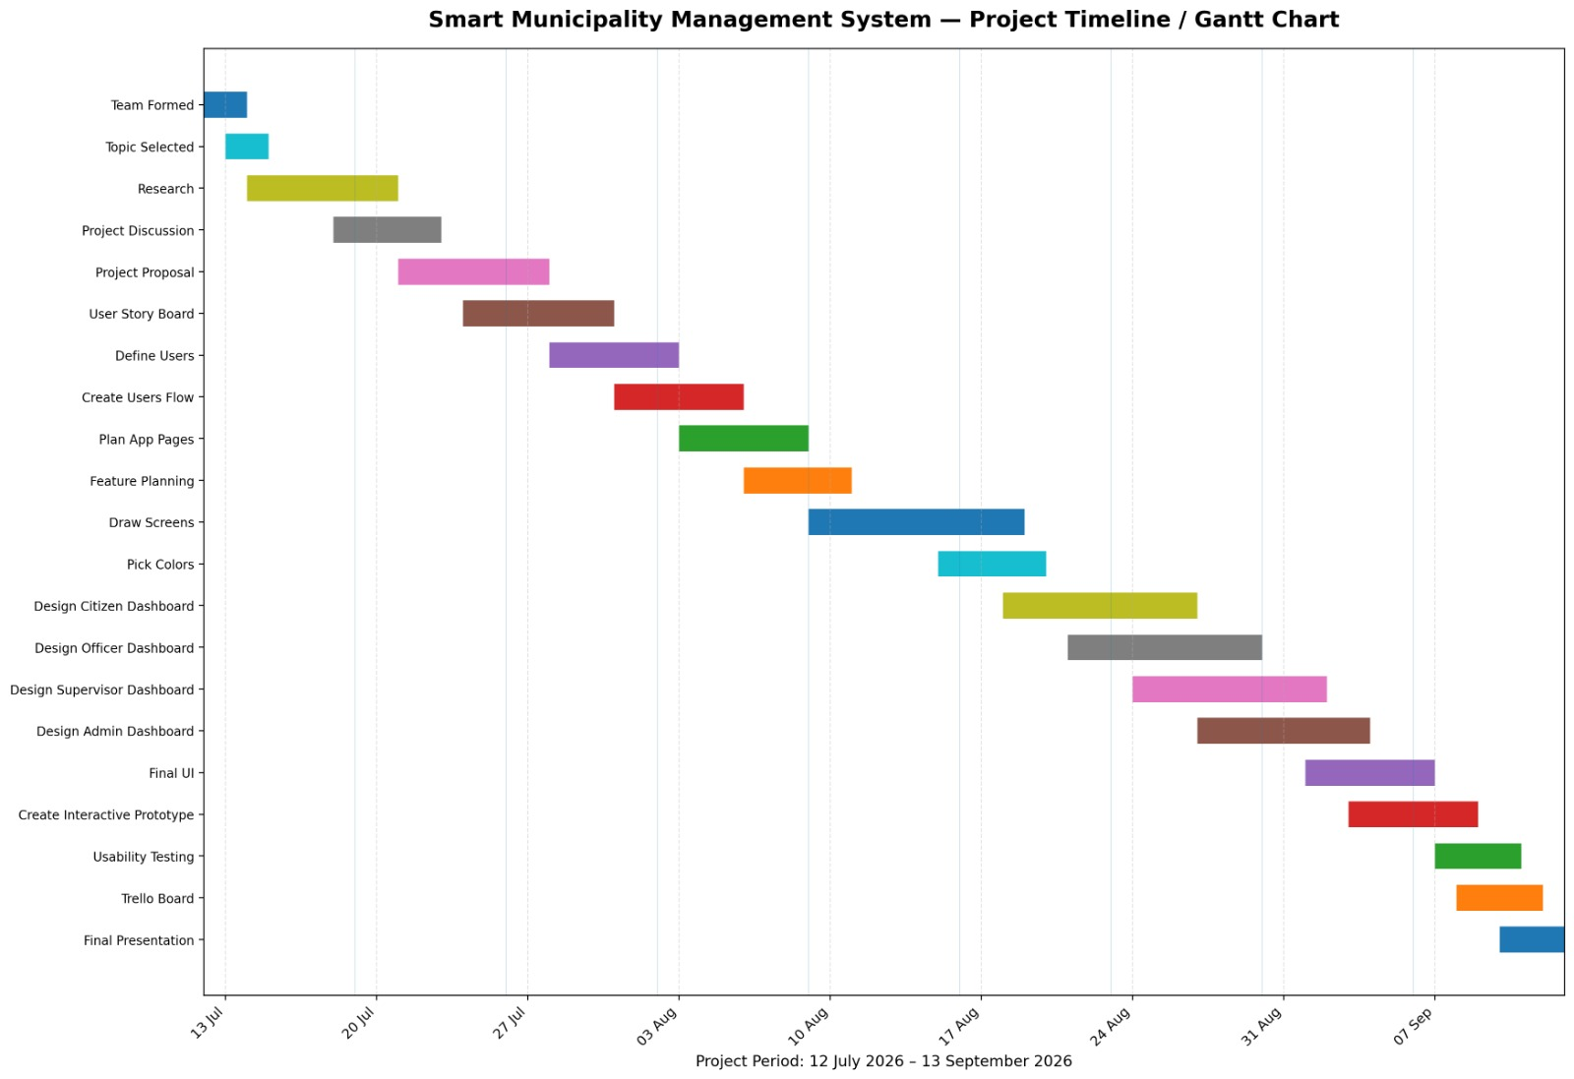
Figure 2.1: Project Timeline / Gantt Chart

Task | Start Date | End Date | Duration (days)
Team Formed | 12 Jul 2026 | 14 Jul 2026 | 3
Topic Selected | 13 Jul 2026 | 15 Jul 2026 | 3
Research | 14 Jul 2026 | 21 Jul 2026 | 8
Project Discussion | 18 Jul 2026 | 23 Jul 2026 | 6
Project Proposal | 21 Jul 2026 | 28 Jul 2026 | 8
User Story Board | 24 Jul 2026 | 31 Jul 2026 | 8
Define Users | 28 Jul 2026 | 3 Aug 2026 | 7
Create Users Flow | 31 Jul 2026 | 6 Aug 2026 | 7
Plan App Pages | 3 Aug 2026 | 9 Aug 2026 | 7
Feature Planning | 6 Aug 2026 | 11 Aug 2026 | 6
Draw Screens | 9 Aug 2026 | 19 Aug 2026 | 11
Pick Colors | 15 Aug 2026 | 20 Aug 2026 | 6
Design Citizen Dashboard | 18 Aug 2026 | 27 Aug 2026 | 10
Design Officer Dashboard | 21 Aug 2026 | 30 Aug 2026 | 10
Design Supervisor Dashboard | 24 Aug 2026 | 2 Sep 2026 | 10
Design Admin Dashboard | 27 Aug 2026 | 4 Sep 2026 | 9
Final UI | 1 Sep 2026 | 7 Sep 2026 | 7
Create Interactive Prototype | 3 Sep 2026 | 9 Sep 2026 | 7
Usability Testing | 7 Sep 2026 | 11 Sep 2026 | 5
Trello Board | 8 Sep 2026 | 12 Sep 2026 | 5
Final Presentation | 10 Sep 2026 | 13 Sep 2026 | 4

